How to create a Page
Starting on the Home Screen and click on Pages from the Menu on the left under Explore:
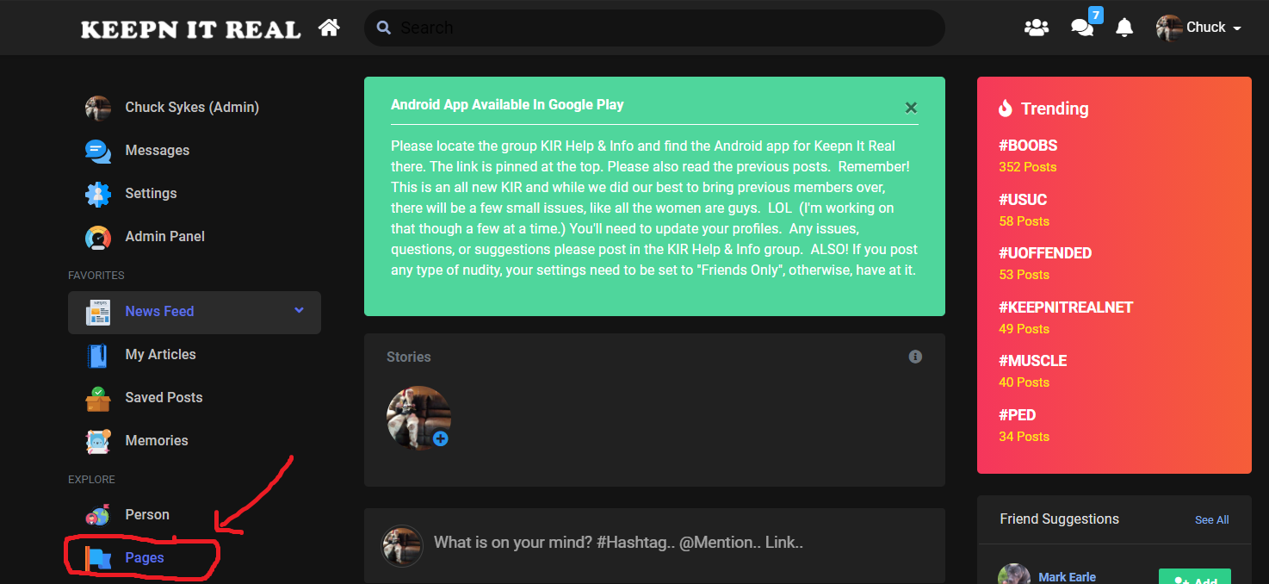
From the page that opens select Create Page on the right hand side of the header.
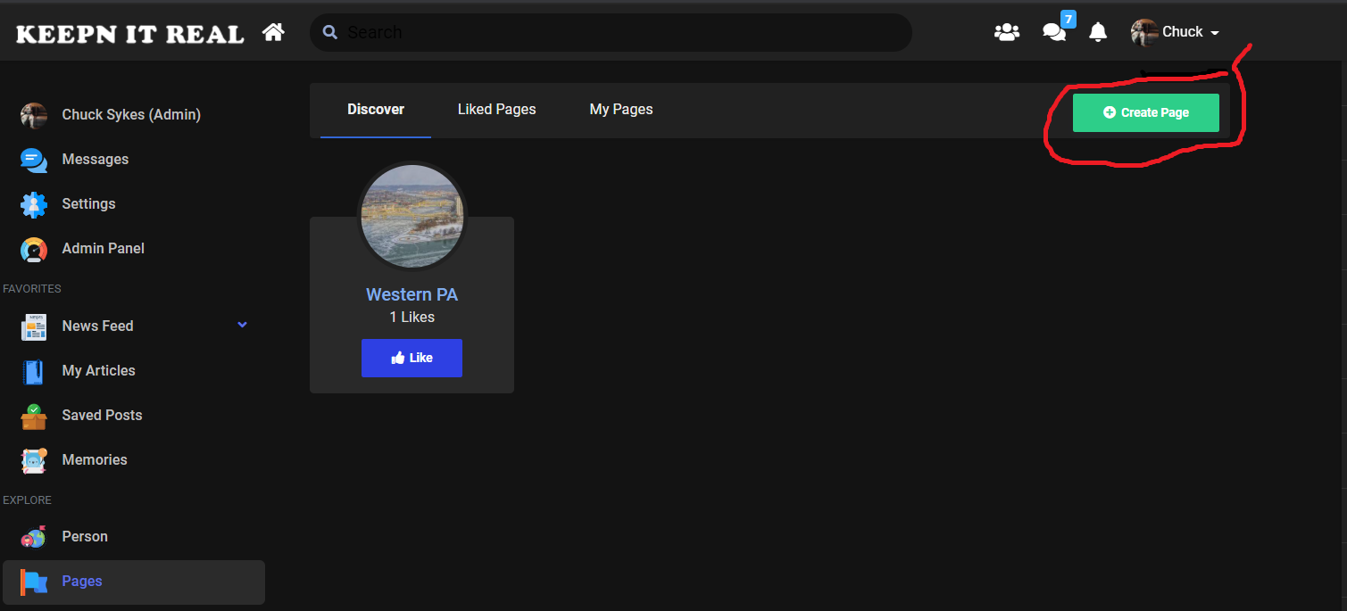
Complete the Form. Enter the Name of your page
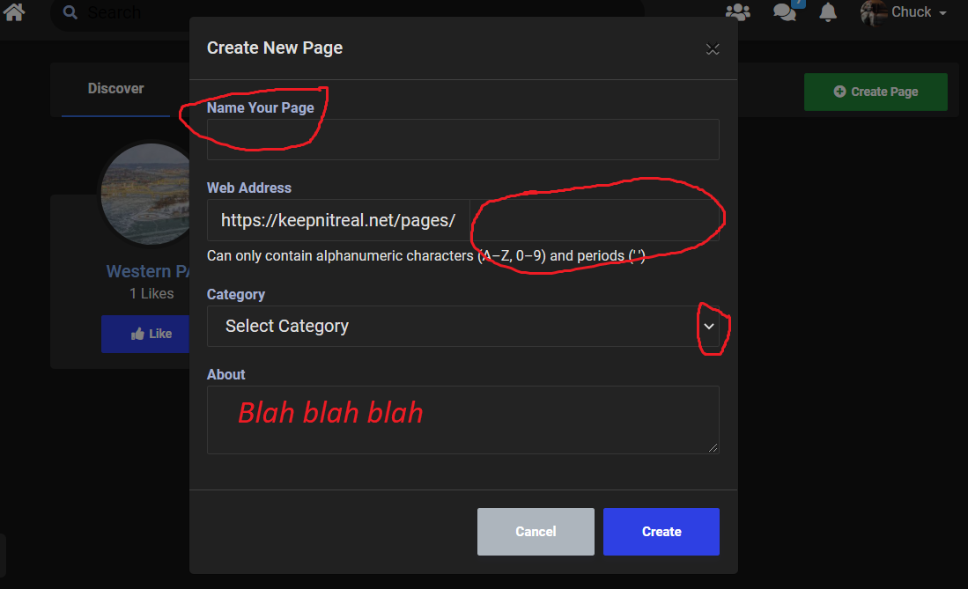
Create a web address, select a category and provide a description in the About section. Then click Create!!!
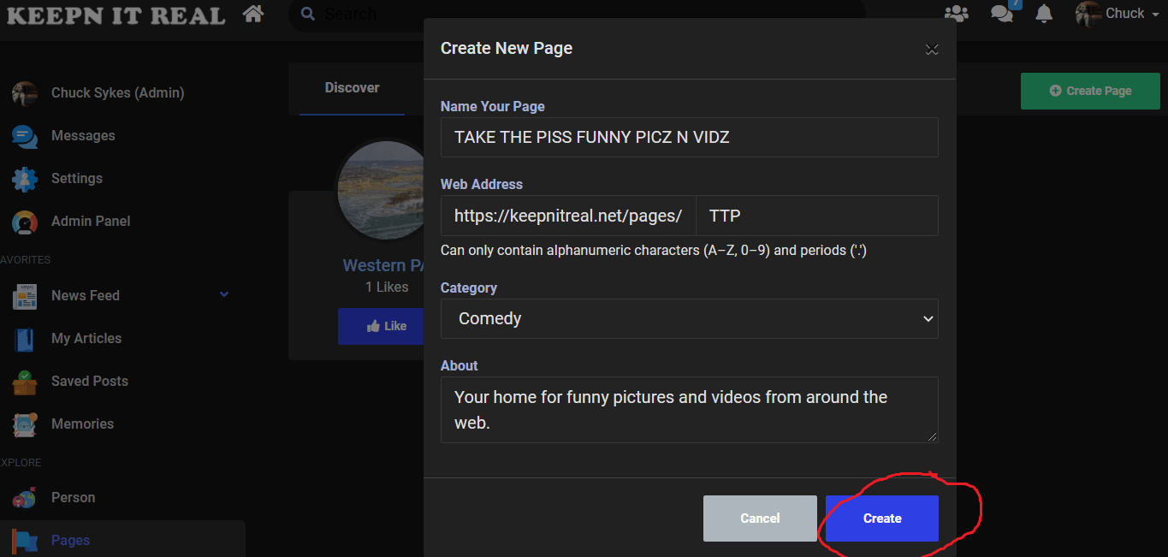
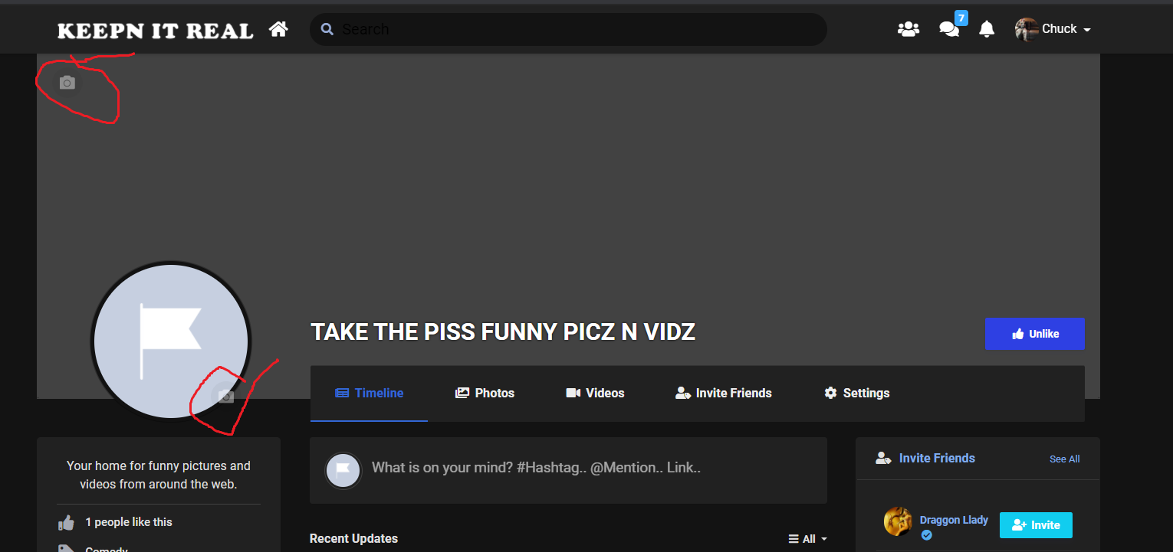
Select the Camera Icon in the upper left hand corner to add your banner image and the Camera Icon next to the Flag to add profile icon.

