Sure, how about "Unlocking the Secrets of 68 game bài"?
In the realm of card games, there exists a fascinating and diverse landscape where strategies, luck, and skill intertwine to create thrilling experiences. Among these games, the enigmatic "68 Game Bài" stands out as a captivating journey into the world of cards. From its origins to its various iterations and strategies, unlocking the secrets of this game unveils a tapestry of excitement and challenge. Join us as we delve into the depths of 68 Game Bài and discover what makes it a timeless classic in the realm of card gaming.
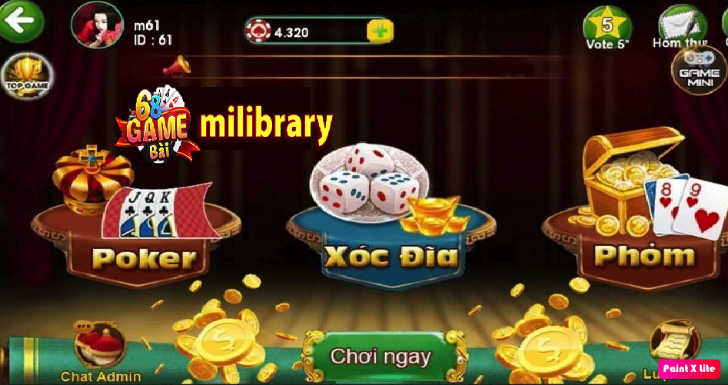
Origins and Evolution:
The roots of 68 Game Bài can be traced back through the annals of time, where its predecessors laid the foundation for the game we know today. Born from a fusion of cultural influences and gameplay mechanics, 68 Game Bài has evolved over the years, adapting to the preferences and nuances of different regions and communities. From its humble beginnings to its modern-day incarnations, each iteration of the game carries with it a rich history and a legacy of entertainment.
Gameplay Mechanics:
At its core, 68 Game Bài is a game of strategy, skill, and chance. Players are tasked with navigating a deck of cards, each holding its own significance and value. From mastering the art of bluffing to strategically managing one's hand, success in 68 game bài hinges on a delicate balance of tactics and intuition. Understanding the intricacies of card combinations, probabilities, and player dynamics is key to emerging victorious in this captivating game.
Strategies and Techniques:
Like any game of skill, 68 Game Bài rewards players who possess a keen understanding of its strategies and techniques. Whether it's employing calculated risks to gain an advantage or deciphering the subtle cues of opponents, mastering the secrets of this game requires dedication and perseverance. From beginner-friendly approaches to advanced tactics, there exists a vast array of strategies waiting to be explored and employed in the quest for victory.
Community and Culture:
Beyond its gameplay mechanics, 68 Game Bài fosters a vibrant community of players who share a common passion for card games. Whether gathered around a table or competing online, enthusiasts of 68 Game Bài come together to celebrate their love for the game and exchange insights and experiences. This sense of camaraderie and camaraderie transcends boundaries, uniting players from diverse backgrounds in the pursuit of shared enjoyment and competition.
Conclusion:
In the ever-expanding universe of card games, few hold the allure and mystique of 68 Game Bài. From its origins rooted in tradition to its modern-day prominence, this captivating game continues to captivate and inspire players around the world. By unlocking the secrets of 68 Game Bài, we gain not only a deeper appreciation for its intricacies but also a glimpse into the timeless appeal of card gaming itself. So, gather your cards, hone your skills, and embark on a journey into the heart of 68 Game Bài – where every hand holds the promise of excitement and discovery.

