What are the chances of love marriage in Birth Chart?

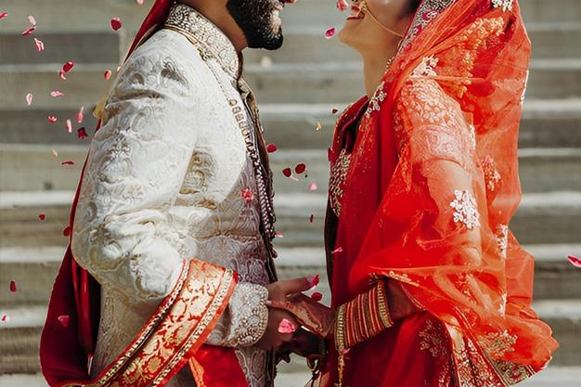

Will I get married for love or will it be fixed according to astrology? This is a familiar problem asked by people of marriageable age to an astrologer. Your horoscope shows the possibilities of love marriage or arranged marriage. Your horoscope will indicate how you will get your life partner.

There are two types of relationships in India, arranged marriage and love marriage, which have been going on for many years.

Love Marriage Based On Planets

Venus is the planet of love with spouse and dreams and love for others is wonderful. This planet is very important for marriage, affection, romance, etc. It provides a general indication for marriage and wife in the case of male natives.

Mars is related to male power. Mars also indicates a lover in the position of a girl's horoscope. Mars indicates attraction or desire within us.

Rahu is the planet of dissatisfied intentions. This is even more important because it is against the rules of the old society. Rahu makes a person sensual and this will create an intention to face life. After Venus, it plays the next important role in the chart to know the love marriage.

Mercury is an often baffling planet that constantly wants to celebrate and revel in life. It shows a youthful childish mood.

Love Marriage Based On Different Houses

For love marriage, we have to survey the 7th, 5th, 8th, and 11th houses. The images we need to understand are Scorpio, Gemini, and Pisces. Mars, Venus, Rahu, Moon, and Mercury planes are responsible. These planets and their hybrids should be surveyed while predicting love marriage astrologers.

The 7th house is an important feature of marriage. It is also important for all types of alliances, such as love affairs or marriage arrangements, and for couples and romantic spouses, etc. It also refers to our marriage and married life. Hence, while searching for a love relationship in astrology, this is the most important house to search for. There can be no prosperity and friendly life in marriage without taking a look at this house.

The 5th house indicates courtship and relationships in our lives. So this is the main house for checking love and romantic life from the chart. Hence, the classification of the 5th house and the 5th lord plays an important role in our lives. The planets in the fifth house are also important for love and romantic life.

8th house signifies physical correspondence, sexual longing, etc. It suggests things that are protected and private. It may not play an important role while surveying love marriage in Kundli but it is important for love and relationship.

The 11th house is also an important house of profit or achievement, burning ambition, and your band of friends.

When does a love marriage happen?

Condition and time are very important parts of our life. The yoga of love marriage may be there, but if there is no good beneficial condition of love and relationship, then the yoga will not be formed. Love marriage yoga is formed only when proper Dasha and yoga are helpful.

Love marriage takes place between the planets belonging to the 5th, 8th, and 11th houses. These 3 houses play a significant role in falling in love or having an emotional connection.

Navamsa chart

When two people are emotionally related and suffering from complexity and discomfort in their relationship and in that case, the parents do not accept the wife, then Navamsa or D9 chart can help you to get rid of it. Navamsa is a very relevant square chart that we can use to survey our marriage prospects in our life and should be borrowed along with the main birth chart to arrive at any decision.

If the d1 chart indicates some optimistic signs of love and romance in your life, then the d9 chart should be surveyed to know if the connection is in trouble.

So in the relation between the 5th and 7th houses in d9, it indicates love marriage. But remember one aspect, no square horoscope can give a result that is not guaranteed in the main chart.

Chirag Daruwalla is the son of Shri Bejan Daruwalla will tell you the right solutions and remedies to get the right solution to the problem related to marriage. You can also take online astrology consultation for the right solution.

