How To Predict Horoscope Matching for Marriage?

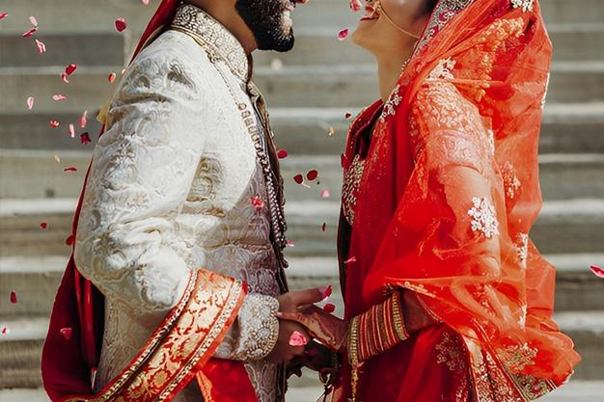

Matching Kundli of boy and girl before marriage is called matching method. It is also known as Kundli matching or Ashtakoot matching. In a common language, it is called Guna matching. Do you know what is this Kundali matching and how is it matched?

Why Match Horoscopes?

1. There should be good mutual harmony between the two.
2. May both be in good health.
3. May both get the pleasure of marriage.
4. Neither of the two should be harmed.
5. Both should not face economic crises.
6. May both get the happiness of children.

Physical, economic, and mental happiness is limited in the above 6 points. Both the boy and the girl should not be deprived of all these three types of pleasures, that is why the marriage horoscope by date of birth is matched. Due to lack of matching, it is believed that if the matching is not proper and still both get married, even if there is no harm, then there may be no harmony between them or they may not get the happiness of children. Sometimes there is a need for a divorce or one of the two becomes a widower or a widow.

These things are seen in the horoscope from the ascendant, fourth, seventh, eighth, and twelfth house respectively. The health of the person from the first, the happiness of household items from the fourth, the cohabitation of men and women from the seventh, long life from the eighth, and the power of buying and selling from the 12th house, etc. are considered.

Each planet is in one of the 12 houses of the magazine at the time of its tour or rotation. In such a situation, if there are malefic planets in these 5 houses or if these 5 houses are aspected by malefic planets and have alliance relations, then more than 40 percent of married life is affected. In such a situation, our sages started the tradition of 'Ashtakoot Milan' to lead a happy, prosperous, and blissful married life.

What is Ashtakoot Matching?

In this, mutual equality, friendship, and the relationship between the birth planets and nakshatras of the boy and the girl are considered. There are 2 differences in mail mentioned in the scriptures. The combination of one planet and the other combination of Nakshatra. On the basis of these two, the education, character, fortune, age, and fertility of the boy and girl are assessed. The 'Ashtakoot' of the constellations and the 9 planets express this mystery.

In Ashtakoota Sutra, the mutual properties of both are divided into 8 parts. These 8 Gunas are based on birth signs and constellation. The zodiac sign and constellation in which the Moon is present at the time of birth in the horoscope both are called the individual zodiac sign and the constellation of the person. The 8 Gunas have been given marks from 1 to 8 respectively, which makes a total of 36. Separate marks are assigned to each guna. Out of these 36 Gunas, the matching is considered correct if at least 19 Gunas are found, but for this, it is necessary to match the Nadi. You can talk to astrologers to know about Nadi Dosha

Varna, Vashya, Tara, Yoni, Maitri, Gana, Bhatuk, and Nadi are matched in Ashtakoot Milan. Ashtakoot matching is not enough. Mangal Dosh is also seen in the horoscope, then the seventh house, seventh lord, planets sitting in the seventh house, and seventh lord, and conjunction of the seventh lord, etc. are also seen.

